Roll No: - 70

Name: - NARKHEDE DIPTI DNYANDEV

Assignment No: -1.1

Assignment: -Develop programs to understand the control structures of Python (Conditional statements).

* if Statement:-

a = int(input(**"Enter marks: "**))  
b = int(input(**"Enter 2nd Number: "**))  
  
if a > b:  
 print(a, **" is greater than "**, b)

* Output:-

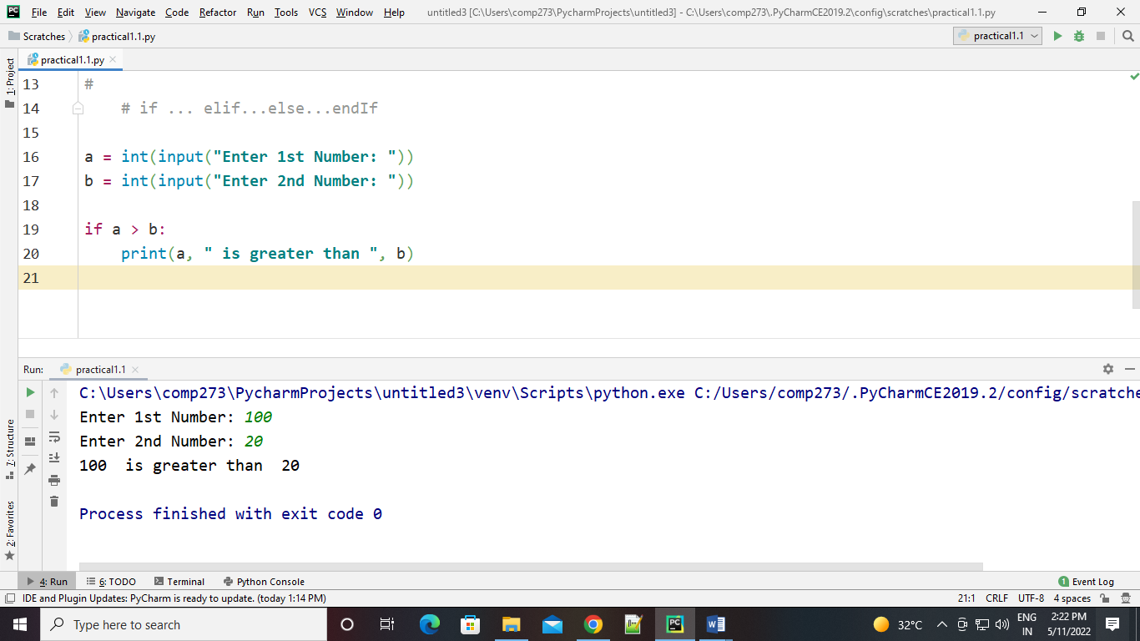

* if…else Statement:-

a = int(input(**"Enter 1st Number: "**))  
b = int(input(**"Enter 2nd Number: "**))  
  
if a > b:  
 print(a, **" is greater than "**, b)  
else:  
 print(a, **" is NOT greater than "**, b)

* Output:-

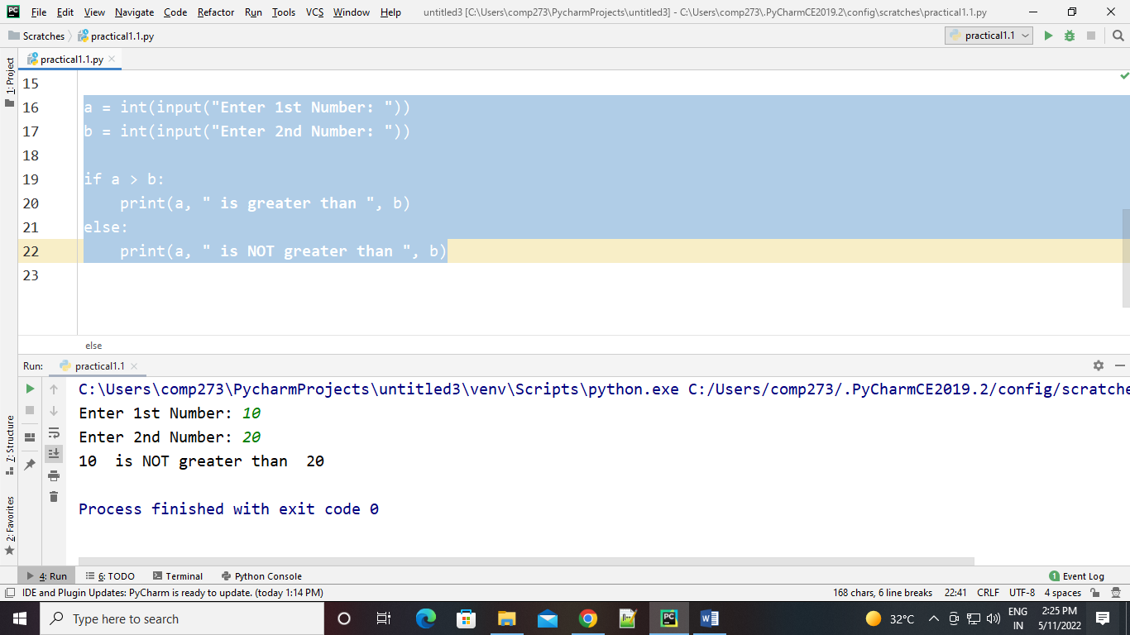

* elif Statement:-

a = int(input(**"Enter 1st Number: "**))  
b = int(input(**"Enter 2nd Number: "**))  
  
if a > b:  
 print(a, **" is greater than "**, b)  
elif a < b:  
 print(a, **" is less than "**, b)

elif a==b:  
 print(**"Both are equal"**)

* Output:-

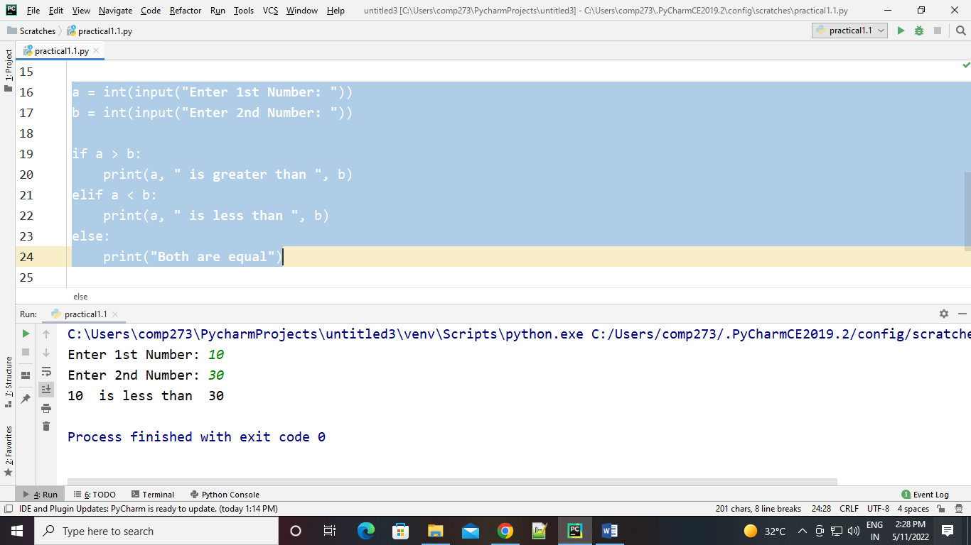

* Nested if:-

num = int(input(**"Enter Number: "**))  
if num >= 0:  
 if num == 0:  
 print(**"Zero"**)  
 else:  
 print(**"Positive number"**)  
else:  
 print(**"Negative number"**)

* Output:-

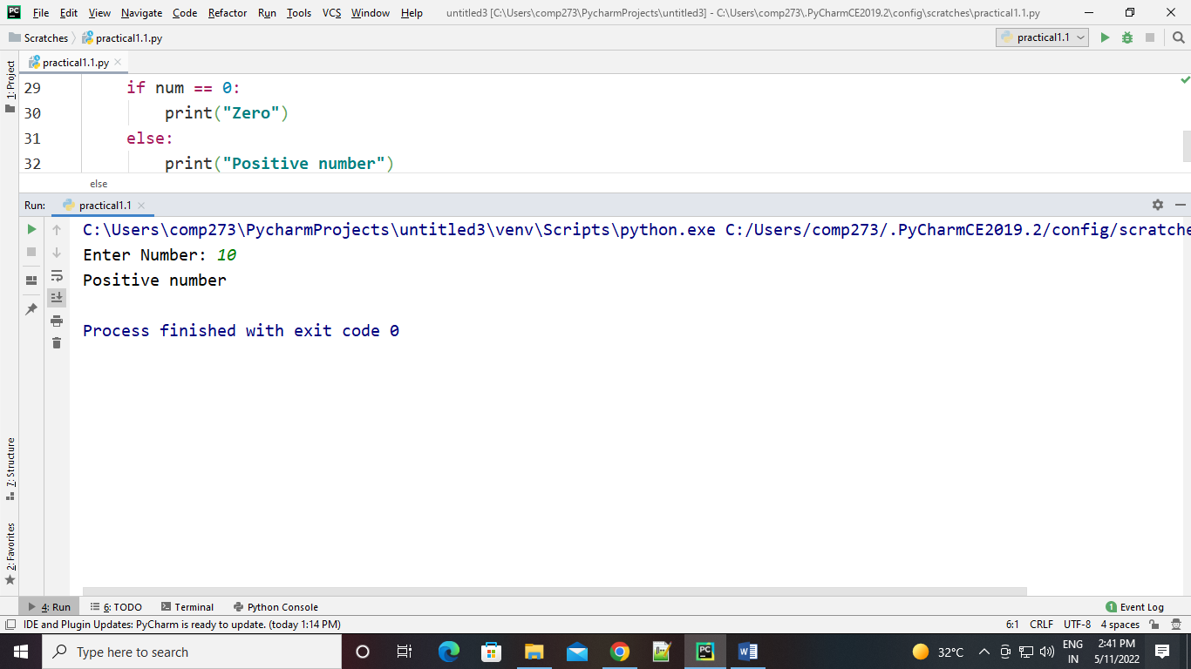

* Elif Ladder:-

a =int(input(**"Enter First Number: "**))  
b =int(input(**"Enter second Number: "**))

if b > a:  
 print(**"b is greater than a"**)  
elif a == b:  
 print(**"a and b are equal"**)  
else:  
 print(**"a is greater than b"**)

* 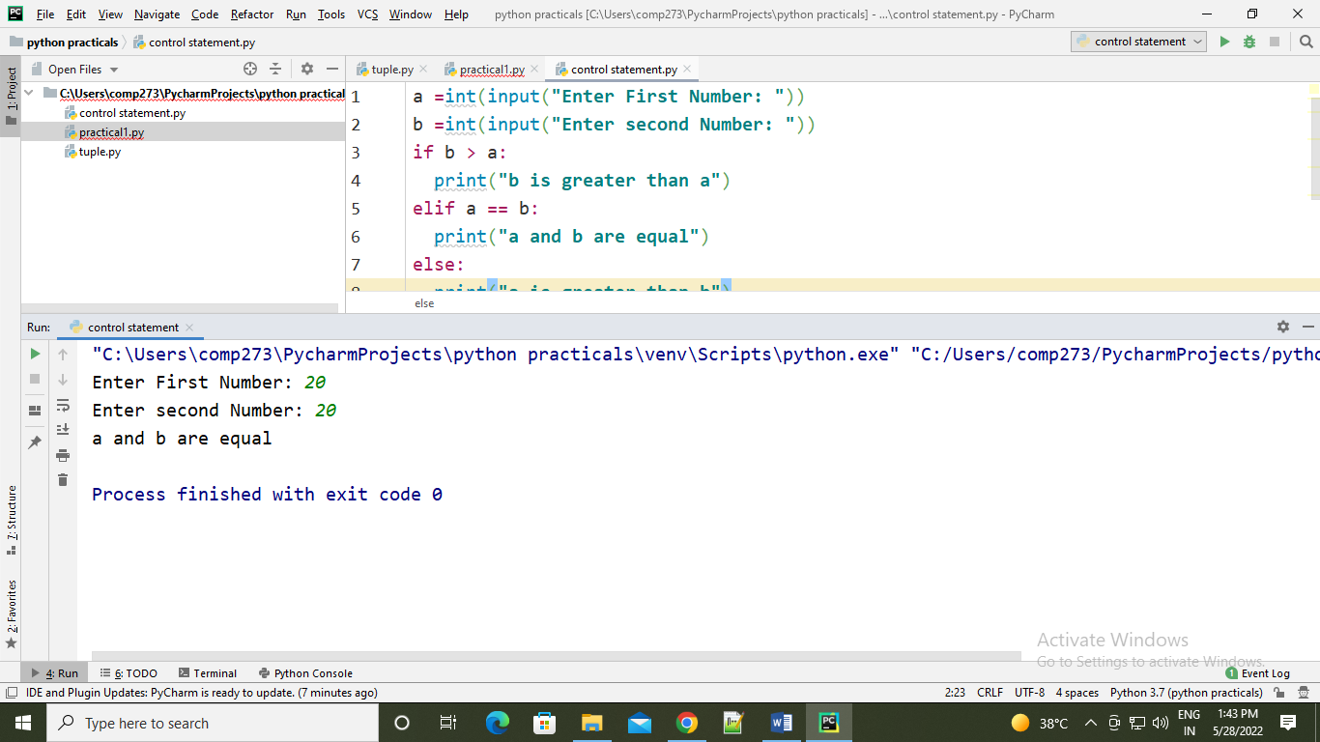Output:-